Topic: Low / Zero Carbon Emission Buildings and Communities (12 pt. Leave one line after)

Template for Full Paper of COBEE2022 (14 pt. Bold. Capitalize the First Letter of Keywords)

Liangzhu (Leon) Wang¹, Michael Lacasse², and Yan Chen^{3, *} (12 pt. Use first name, middle initial, and last name format)

¹Department of Building, Civil, and Environmental Engineering, Concordia University, Montreal, Quebec, Canada (12 pt.)
²Building Envelope and Materials Research Unit, Construction Research Centre, National Research Council, Ottawa, Canada (12 pt.)
³Department of Building Services Engineering, The Hong Kong Polytechnic University, Hong Kong, China (12 pt. leave one empty line after)

*Corresponding email: cobee2022@concordia.ca (12 pt. Leave one empty line after)

Keywords: Maximum five keywords, Capitalize the first word, Separate by a comma (12 pt. Leave one empty line after)

SUMMARY (Times New Roman Bold 12 pt, UPPERCASE, leave a blank line before and after the main level headings)

Prepare an informative summary of up to 150 words for your full paper. The summary should provide information on the purpose of the study, methods or procedures, results, discussion, and concluding remarks. The summary should be a self-contained statement giving the reader a clear indication of the purpose and content of the paper.

INTRODUCTION

The introduction should present the practical and scientific background for the study or presentation, the hypothesis(es), and a clear statement of the objective(s) of the study/presentation. (Leave one blank line between paragraphs throughout)

COBEE2022 allows authors to submit a three-page extended abstract or a full-length paper. This instruction is for the full-length paper. This file can be used as a template by simply replacing the corresponding text with your own. Please submit this full paper in PDF file to the online submission system (https://www.conftool.pro/cobee2022/) by February 1st, 2022. Please name the file of this paper as FP_ID_v1.pdf, where “ID” is the paper number assigned to you by COBEE2022. The “v1” stands for version 1. For example, a paper file can look like FP_211_v1.pdf.

The maximum length is eight pages for a full paper, including references, figures, and tables. Please use Letter size format (21.59 cm × 27.94 cm) when preparing your paper. All margins should be set to 25 mm. Use single-column format. All text should be justified using Times New Roman font with 12 pt size. Leave a blank line between paragraphs and before and after the main level heading. Please use 12 pt UPPERCASE bold font for main headings and 12 pt normal lowercase (The first letter capitalized) bold font for 2nd level headings. Avoid use 3rd level headings. Please do not number the pages.

METHODS

This section should describe the study design, materials, measurement methods and procedures, and statistical methods. Measurement and statistical methods should be mentioned, but a reference rather than a description of the method is recommended for routine methods.

The full papers must provide new information on scientific validation, comparative testing, research, or development. Commercialism is not allowed.

RESULTS

Please do not simply present results but provide overall comments on the findings and their applicability in other settings or applications. In addition, you should conduct analyses of the results for readers.

Tables and illustrations (Times New Roman Bold 12 pt, Lowercase for 2nd level heading)
In general, figures and other illustrations should be used when they are shorter, clearer, or more effective than explanations in words. Avoid tables and figures that duplicate each other or present redundant data. If you use a figure, do not include a table for the same information. Substitute a few typical results for long tables when practical. A table must have a suitable caption above it, and a figure must have a caption below it. Use a three-line table as shown in Table 1. Tables and figures should be inserted in the text near to the place they are mentioned the first time. Please insert figures as ‘picture’ (e.g., wmf or jpg), not as ‘objects’ or spreadsheets. Do not extend figures or tables beyond the margins. Please do not shrink the figures too small. Your eye resolution is the same for the text in a paragraph or in a figure.
(Leave one blank line before and after tables, figures, and equations)

Table 1. The unique EHY of each city [1]. (Italic table caption)
City | Unique EHY | Extreme heatwave
 |  | Severity (℃∙h) | Intensity (℃)
Ottawa | 2010 | 436.5 | 2.6
Montreal | 2010 | 521.7 | 3.2
Toronto | 2013 | 431.9 | 3.0
Baltimore | 2006 | 1088.1 | 3.5
Phoenix | 1992 | 3924.4 | 3.9
Houston | 2005 | 12418.1 | 5.1
[leave one blank line between a table and the following text]
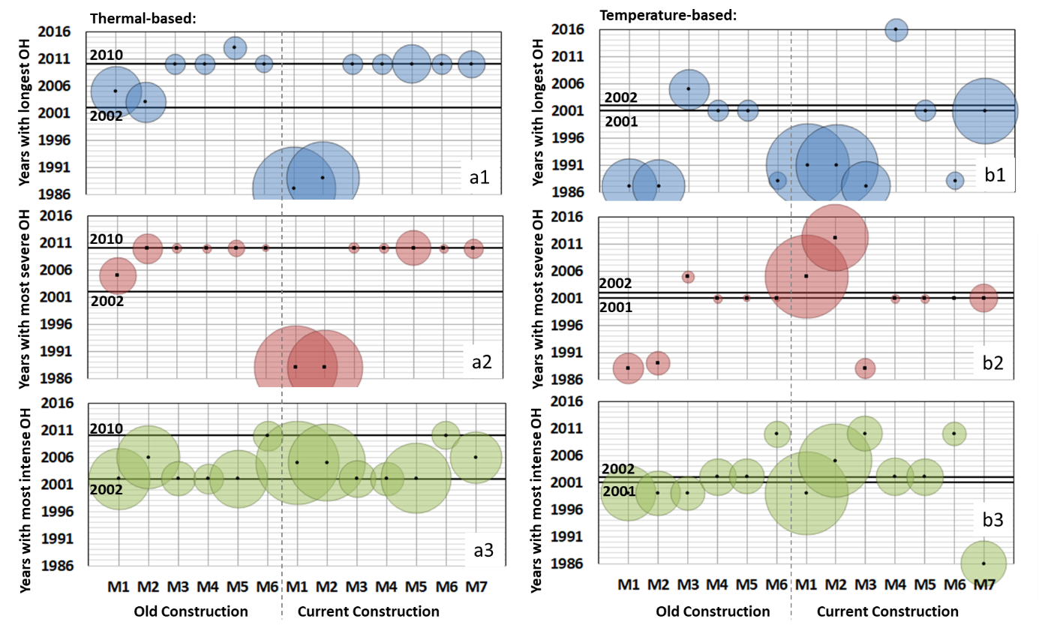
Figure 1. Indoor extreme years and the overheating (OH) magnitude (relative) for the single-detached house with various configurations in Ottawa (Ontario). Note the black dots represent the indoor extreme year of each configuration, the size of the bubbles means the duration (Blue), severity (Red), and intensity (Green) of the indoor overheating; the two solid lines in each subfigure correspond to outdoor extreme years [1].
[leave one blank line between a figure and a table]

Equations
Equations should be numbered at the right margin, as in the example below (Leave one blank line before and after an equation or between equations):

$ETH=\sum_{N}{{\text{SETH}}_{\text{d}}\text{+}{\text{SETH}}_{\text{n}}= \sum_{dayhour}{{\left[\text{t-SET -} {\text{t-SET}}_{\text{d}}\right]}^{+}}+}\sum_{nighthour}{{\left[\text{t-SET -} {\text{t-SET}}_{\text{n}}\right]}^{+}}$ (1)

where N is the duration (in days) of a heat event, ${SETH}_{\text{d}}$ is its severity during the daytime, ${SETH}_{\text{n}}$ is for the preceding night time severity, $\text{t-SET}$ is the hourly value during day or night time, t-SET_{d} and t-SET_{n} are the t-SET threshold values during day and night time, respectively. Use italic symbols for quantities and variables. Punctuate equations with commas or periods when they are part of a sentence.

Names and units
Only use the metric system (SI units). Frequently used technical terms may be abbreviated after the first time they are mentioned: “Ventilation has proved to be an effective solution for reducing building cooling load in high-rise buildings, i.e., ventilative cooling (VC), especially in cold climates [2]”.

DISCUSSION

The most important findings of the paper should be put into perspective with prior knowledge. In addition, possible sources of error that may affect the interpretation of the results should also be discussed.

Discussion should also present the authors’ interpretation of the meaning of the results. The authors are encouraged to make recommendations on the basis of the earlier knowledge and the present results.

The discussion of implications should tell readers the importance of the work for others, including researchers, building designers, owners, and operators, or occupants.

CONCLUSIONS

The conclusions must be supported by the findings detailed in the RESULTS section. They should be solid, novel, and concise.

ACKNOWLEDGEMENT

You may acknowledge the supports and assistance provided by others to your paper. Sources of financial aid should also be noted.

REFERENCES

Cite the literature by using the IEEE style, which is commonly available in the reference management tool, such as EndNote and Mendeley. A single author’s name and two authors’ names should be included in the text. For three or more authors, use the last name of the first author with “et al.”. For example:

Chen [3] proposed a program by coupling an energy simulation program with CFD.

A paper published by Chen and Wang [4].

Hanzawa et al. [5] found that a feeling of thermal comfort is related to airspeed.

If the “author” is an organization, use initials. For example:

ASHRAE Standard 55 [6] has used the work from other people [5], [7] in its standard….

[1] L. Ji, A. Laouadi, C. Shu, A. Gaur, M. Lacasse, and L. Wang, “Evaluating approaches of selecting extreme hot years for assessing building overheating conditions during heatwaves,” Energy Build., vol. 254, p. 111610, 2022.
[2] H. Sha, M. Moujahed, and D. Qi, “Machine learning-based cooling load prediction and optimal control for mechanical ventilative cooling in high-rise buildings,” Energy Build., vol. 242, p. 110980, 2021.
[3] Q. Chen, “Indoor airflow, air quality and energy consumption of buildings,” Ph.D. Thesis, Delft University of Technology, 1988.
[4] Q. Chen and L. Wang, “Coupling of multizone program CONTAM with simplified CFD program CFD0-C. Final Report for NIST RFQ-03-Q-9537,” School of Mechanical Engineering, Purdue University, West Lafayette, Indiana, 2004.
[5] H. Hanzawa, A. K. Melikow, and P. O. Fanger, “Airflow characteristics in the occupied zone of ventilated spaces,” ASHRAE Trans., vol. 93, no. 1, pp. 524–539, 1987.
[6] ASHRAE, ANSI/ASHRAE 55-Thermal Environmental Conditions for Human Occupancy. Atlana, GA, USA: American Society of Heating, Refrigerating and Air-Conditioning Engineers (ASHRAE), 2013.
[7] P. O. Fanger, Thermal Comfort. Copenhagen, Denmark: Danish Technical Press, 1970.

